Summary
In this lab, you’ll configure the play area for your game by:
- Creating and configuring one wall
- Duplicating and placing it to create a contained game area
1. Overview
In this lab, you’ll configure the play area for your game by:
- Creating and configuring one wall
- Duplicating and placing it to create a contained game area
2. Create a wall for the play field
1. Create an empty parent GameObject.
- In the Hierarchy window, right-click > Create Empty, then rename it “Walls”.
- In the Inspector window, reset its Transform component.
2. Create a Wall child GameObject.
- In the Hierarchy window, right-click > 3D Object > Cube, then rename it “West Wall”.
- In the Inspector window, reset the West Wall GameObject’s Transform component.
- Drag the West Wall GameObject onto the Walls GameObject. This makes the West Wall GameObject a child GameObject of the Walls GameObject.
3. Set the Wall’s transform values.
- Press the F key while the cursor is over the Scene view to frame the West Wall GameObject in the view.
- In the Inspector window, change the wall’s Transform Scale values to X=0.5, Y=2.0, Z=20.5.
- Set the Transform's Position X value to -10.
- This places the West Wall GameObject neatly on the edge of the play area.
4. Create a material for the walls.
- In the Project window, go to the Materials folder, then right-click > Create > Material.
- Rename this new material “Walls”.
- In the Inspector window, select the Base Map color field to open the color picker, then set the RGB values to 79, 79, 79 for a darker gray.
- Set the Metallic Map to 0 and change the Smoothness to 0.25, for a matte finish.
- Drag the Walls material from the Project window onto the West Wall GameObject in the Scene view.
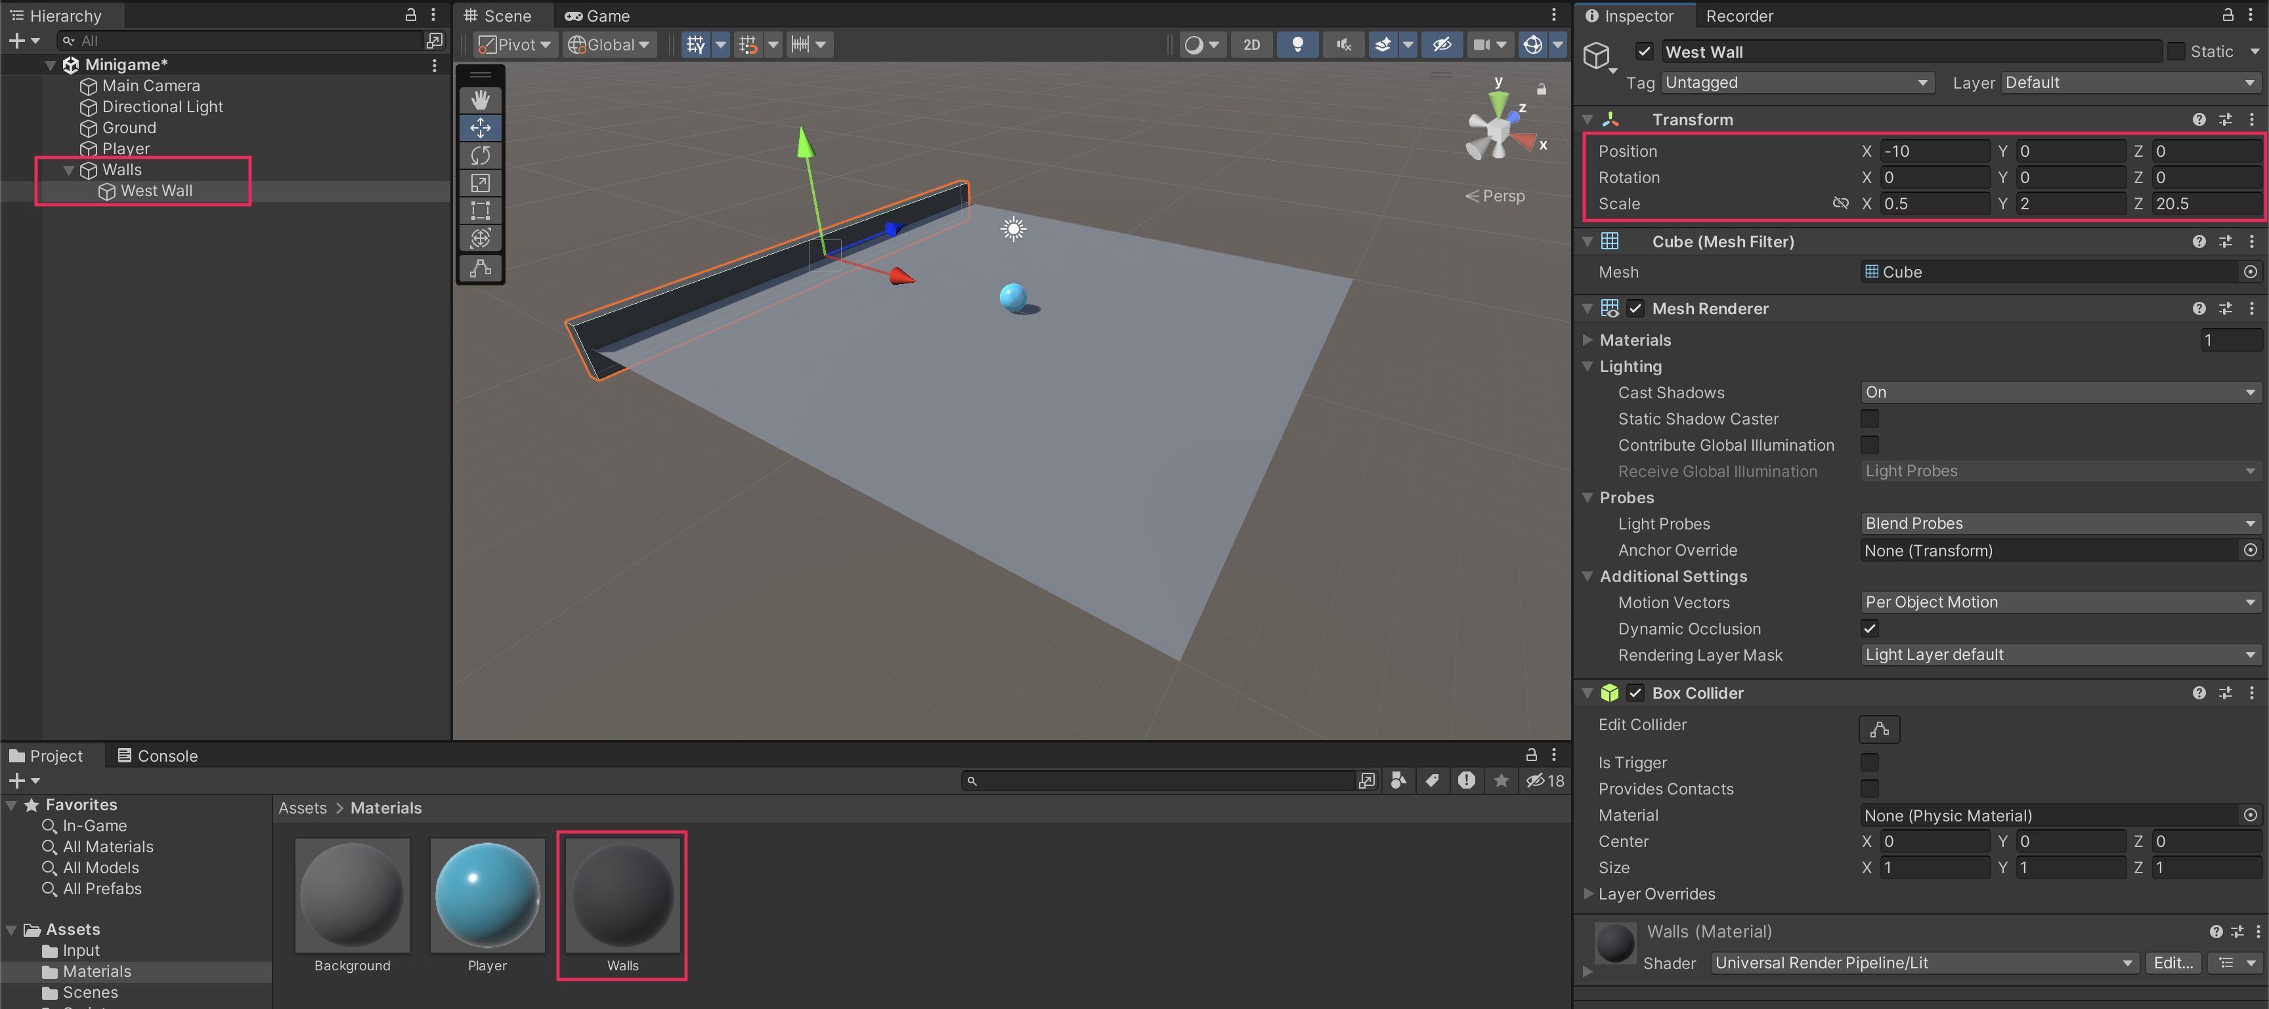
3. Finish the play field walls
1. Create the East wall.
- Right-click the West Wall GameObject and select Duplicate.
- Rename the new GameObject “East Wall”.
- To reposition the wall, remove the negative sign in the Position X value of the Transform component.
2. Create the North and South walls.
- Duplicate the East Wall GameObject and rename the duplicate “North Wall”.
- Set the Rotation Y value to 90.
- Set its Position X value to 0 and its Position Z value to 10.
- Duplicate North Wall GameObject, rename it “South Wall”, and set its Position Z value to -10.
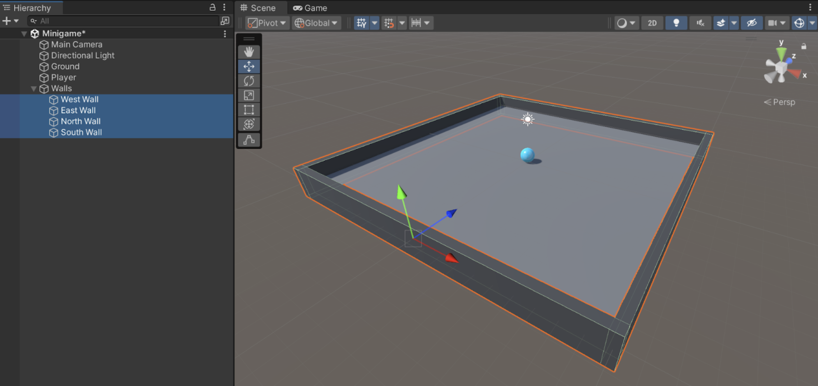
3. Test the game.
- You should now be able to roll around and bump into the walls.
- If the ball is going through the walls, make sure that the IsTrigger property in the Collider component is disabled.

